**MINISTRY OF EDUCATION AND TRAINING**

**FPT UNIVERSITY**

Capstone Project Document

The Traffic Sign Recognition and Training

|  |  |
| --- | --- |
| **Group 2** | |
| **Group member** | Mai Văn Tân – Team Leader – SE90061  Bùi Việt Phong – Team Member - SE60747  Hồ Đắc Nghĩa – Team Member - SE60628 |
| **Supervisor** | Mr. Kiều Trọng Khánh |
| **Ext. Supervisor** | N/A |
| **Capstone Project code** | TSRT |

-Ho Chi Minh City, 03/2014-

*This page is intentionally left blank*

***ACKNOWLEDGEMENTS***

# Table of Contents

**Table of Contents 4**

**List of Tables 7**

**List of Figures 9**

Definitions, Acronyms, and Abbreviations 13

Report No 5 - System Implementation & Test 14

1. Introduction 14

1.1 System Overview 14

1.2 Test Approach 14

2. Database Relationship Diagram 15

3. Performance measures 16

3.1 Face Detection Performance 16

3.2 Face recognition performance 16

4. Test Plan 18

4.1 Features to be tested 18

4.2 Features not to be tested 18

5. System Testing Test Case 19

6. Module Test Case 22

6.1 Manage RollCall 22

6.2 Manage Student Image 24

6.3 Check Attendance 27

6.4 Attendance Report 30

6.5 Manage Teaching Calendar 31

6.6 Manage Study Session 33

6.7 Check own Attendance Rate 35

# List of Tables

Table 1: Core Workflow Test Case 16

Table 2: Manage Roll Call Test Case 18

Table 3: Manage Student Image Test Case 21

Table 4: Check Attendance Test Case 24

Table 5: Attendance Report Test Case 25

Table 6: Manage Teaching Calendar Test Case 27

Table 7: Manage Study Session Test Case 29

Table 8: Check own Attendance Rate Test Case 30

# List of Figures

Figure 1: ERD - Physical Diagram 9

Figure 2: Face Recognizer Algorithm Accuracy 10

Figure 3: Number of images required 11

Figure 4: Full Recognize Percent 11

Figure 5: Core Workflow 13

# Definitions, Acronyms, and Abbreviations

# Report No 5 - Software Test Documentation Guide Implementation

## Introduction

### System Overview

This section provides in detail all necessary information about test plans, test cases, test result, test environments, pass/fail criteria and risks estimations as well as a checklist to cover all possible cases of TSRT.

### Test Approach

- Goal: To test the whole system based on the core workflow.

- Method: System Testing, Black-box Testing.

## Database Relationship Diagram

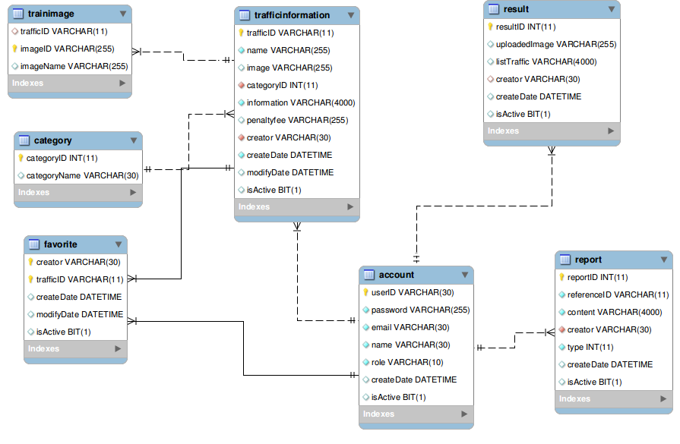

Figure 70: Database Relationship Diagram

## Performance measures

### Traffic Sign Detection Performance

With image resolution: 800x460px

Web module: Ubuntu 13.10 with core i3 M350 2.27GHz, 3GB Ram

* Average time to detect traffic sign:
* Best traffic sign detected result: 60/84 traffic sign. Percent: 71.4%
* Worst traffic sign detected result: 56/84 traffic sign. Percent 66.7%

Mobile module: Android 4.0 with 2 cores 1GHz, 512MB Ram

* Average time to detect traffic sign: 0.357s (2.8 FPS)

### Traffic Sign Recognition Performance

With image resolution: 800x460px

Web module: Ubuntu 13.10 with core i3 M350 2.27GHz, 3GB Ram

* Best time to run traffic sign recognition: 0.013s
* Worst time to run traffic sign recognition: 0.016s

Recognition accuracy (good condition):

Figure 71: Traffic Sign Recognition Accuracy

## Test Plan

The purpose of this section is to verify and ensure that TSRT meets its design specification and other requirements from user. The following part will describe which features to be tested and which will not.

### Features to be tested

We will test the entire system based on the following core workflow (Reference: **Figure 101: Core Workflow**).

Based on the workflow, all following features will be tested, which can include one or more functions. These features will be focused and tested thoroughly during the test phase.

* Manage traffic sign
* Manage report
* Search auto: Search auto on both website and mobile (Include search by take picture or upload image).

### Features not to be tested

* Register
* Login, Logout
* Forgot Password
* User - View, delete history and favorite.
* Admin – Manage Account, Configure System, Make statistic
* Staff – Manage Account, Make statistic, Import, Export file

## System Testing Test Case

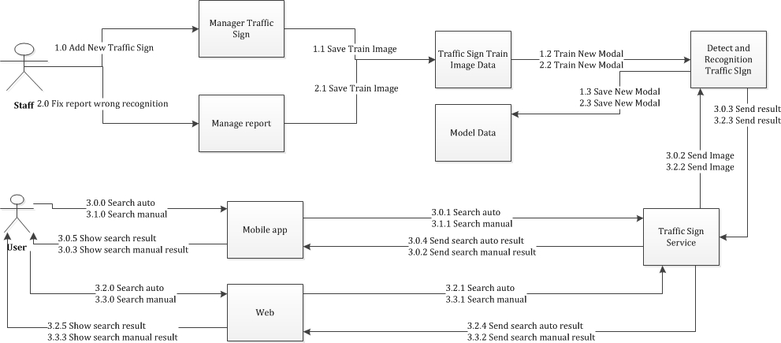

**Figure 72: Core Workflow**

|  |  |  |  |  |  |  |
| --- | --- | --- | --- | --- | --- | --- |
| **ID** | **Test Case Description** | **Test Case Procedure** | **Excepted output** | **Result** | **Test Date** | **Note** |
| ST01 | Staff add new traffic sign (In this case staff have information of traffic sign as well as image of traffic sign) | 1. Login into the system using a staff account 2. On the staff home page, click “Quản lý biển báo”, then click “Thêm mới” button. 3. Input traffic sign formation:   -Label  -Name  - Image  - Type  - Information  - Penalty fee  - Train image   1. Press “Lưu” button | -After step 2, the modal add new will popup.  -After step 3 the page will fresh and the new traffic now in table traffic sign list | Passed | 14/04/2014 |  |
| ST02 | Staff fix a wrong recognition from report | 1 - Login into the system using a staff account  2 - On the staff home page, click “Quản lý phản hồi”, select a wrong recognition row and press “Chi tiết” button  3 - Press in “Sửa” link  4 – On the new page, move the mouse to the detected area, and input name to find traffic sign  5 – Press “Xóa” button | * After step 2, a modal popup and show detail of the report * After step 3, the page will direct to Add train image from report * After step 5, the page will direct back to report manage page |  | 14/04/2014 |  |
| ST01 | User take a picture to search traffic sign automatically (Mobile) | 1 – Select the application’s icon to launch.  2 – On the main screen, select button “Nhận dạng biển báo”.  3 – Move the camera into traffic sign area with suitable angle (less than 30 degree).  4 – Select the “Camera” icon to take picture. | - After step 3, transfer to camera screen.  - After step 3, there will be a pink frame that surround the traffic sign  - After step 4, the popup will show “Vui lòng đợi trong giây lát”.  - After that screen will show the result of recognize, include: + Picture was taken. + Result of recognize. | Passed | 10/04/2014 |  |
| ST02 | User search manual by enter key word.(Mobile) | 1 – Select the application’s icon to launch.  2 – On the main screen, select button “Tra cứu biển báo”.  3 – Enter the search key: “quay xe”  4 – Select search button.  5- On the result screen, select one traffic sign. | - After step 2, transfer to search manual screen, include:  + Text field to enter search key  + Search button  + 4 traffic sign’s category  - After step 4, transfer to result screen and display search result (Contain 3 traffic signs)  - After step 5, transfer to traffic sign detail screen, show all the information of traffic sign, include: Image, ID, name, information and penalty fee (if available). | Passed | 10/04/2014 |  |
| ST03 | User upload picture to search auto (Website). | 1 – Click link “Nhận dạng tự động” in main menu.  2 –Select browse button to select image to upload. | - After step 1, redirect to search auto page.  - After step 2, display loading bar show the upload progress.  - After that, the search result display in the left column and uploaded image was display in the right. | Passed | 10/04/2014 |  |
| ST04 | User search manual in the web. | 1 – Click link “Tra cứu biển báo” in main menu.  2 –Enter the search key in the text box : “quay xe”  3- Select type of category: “Tất cả”.  4- Click button ”Tìm kiếm”.  5- Click one traffic sign’s name. | - After step 1, redirect to search manual page.  - After step 4, show the table contain search result (3 records).  - After step 4, show the popup, display all the information of traffic sign, include: Image, ID, name, information and penalty fee (if available). | Passed | 10/04/2014 |  |

**Table 42: Core Workflow Test Case**

## Module Test Case

### Manage Traffic Sign

|  |  |  |  |  |  |  |  |
| --- | --- | --- | --- | --- | --- | --- | --- |
| **ID** | **Test Case Description** | **Test Case Procedure** | **Excepted output** | **Inter-test Case Dependence** | **Result** | **Test Date** | **Note** |
| MT01 | View traffic list | 1 – Login into the system using a staff account  2 – Click the “Quản lý biển báo” in the menu bar | -A table traffic sign is showed |  | Passed | 14/04/2014 |  |
| MT02 | Edit a traffic sign information | 1 – Find the traffic sign need to edit information and click “Sửa” button  2 – Input new traffic sign information (if necessary):   * Name * Image * Type * Content * Penalty fee * Train image   3 – Press “Lưu” button | -After the step 1, a edit traffic sign modal popup with old information of traffic sign  -After the step 3, the page will refresh and the information of traffic sign is updated | MT01 | Passed | 14/04/2014 |  |
| MT03 | Delete a traffic sign | 1 – Find the traffic sign need to edit information and click “Xoá” button | -The page will refresh and the traffic disappear from the table | MT01 | Passed | 14/04/2014 |  |
| MT04 | Filter traffic sign by type | 1 – From traffic sign manage page, select traffic sign type in “Loại biển báo” dropdown list | -The page will refresh and the table of traffic sign list only contain the traffic sign have type match with selected type | MT01 | Passed | 14/04/2014 |  |

**Table 43: Manage Traffic Sign Test Case**

### Manage Report

|  |  |  |  |  |  |  |  |
| --- | --- | --- | --- | --- | --- | --- | --- |
| **ID** | **Test Case Description** | **Test Case Procedure** | **Excepted output** | **Inter-test Case Dependence** | **Result** | **Test Date** | **Note** |
| MR01 | View list report | 1 – Login the system with a staff account  2 – Click on “Quản lý phản hồi” menu | -A table contain list report is showed |  | Passed | 14/04/2014 |  |
| MR02 | View a report detail | 1 – From manage report page, find the report and click “Chi tiết” button | -A modal popup will show the detail of report | MR01 | Passed | 14/04/2014 |  |
| MR03 | Delete a report | 1 – From manage report page, find the report and click “Xóa” button | -Page will refresh and the report disappear | MR01 | Passed | 14/04/2014 |  |
| MR04 | Filter report by type | 1 – From manage report page, select a type in “Loại phản hồi” dropdown list | -Page will refresh and show the report table with only report type match with selected type | MR01 | Passed | 14/04/2014 |  |
| MR04 | Edit a report wrong information | 1 – From manage report page, find a wrong information report and click “Chi tiết”  2 – Click “Sửa” link in modal popup  3 – Input new information of traffic sign (if necessary):   * Name * Image * Type * Content * Penalty fee * Train image   4 – Press “Lưu” button | -Page will refresh and the information of traffic sign is changed | MR01 | Passed | 14/04/2014 |  |

**Table 44: Manage Report Test Case**

### Search auto

|  |  |  |  |  |  |  |  |
| --- | --- | --- | --- | --- | --- | --- | --- |
| **ID** | **Test Case Description** | **Test Case Procedure** | **Excpected output** | **Inter-test Case Dependence** | **Result** | **Test Date** | **Note** |
| SA01 | Search auto by take picture by hand. (Mobile) | 1 – Select the application’s icon to launch.  2 – On the main screen, select button “Nhận dạng biển báo”.  3 – Move the camera into traffic sign area with suitable angle (less than 30 degree).  4 – Select the “Camera” icon to take picture. | - After step 2, transfer to camera screen.  - After step 3, there will be a pink frame that surround the traffic sign  - After step 4, the dialog will show “Vui lòng đợi trong giây lát”.  - After that screen will show the result of recognize, include: + Picture was taken. + Result of recognize. |  | Passed | 10/04/2014 |  |
| SA02 | Search auto by take picture auto.  (Mobile) | 1 – Select the application’s icon to launch.  2 – On the main screen, select button “Nhận dạng biển báo”.  3 – Select button “auto on” to turn on auto mode  4 – Move the camera into traffic sign area with suitable angle (less than 30 degree).  5 – Hold camera steady, until “Auto captured” message show. | - After step 2, transfer to camera screen.  - After step 4, there will be a pink frame that surround the traffic sign  - After step 5, the dialog will show “Vui lòng đợi trong giây lát”.  - After that screen will show the result of recognize, include: + Picture was taken. + Result of recognize. |  | Passed | 10/04/2014 |  |
| SA03 | Search auto by upload picture. (Mobile) | 1 – Select the application’s icon to launch.  2 – On the main screen, select button “Nhận dạng biển báo”.  3- Click “upload” button then select image. | - After step 3, transfer to camera screen.  - After step 3, the dialog will show “Vui lòng đợi trong giây lát”.  - After that screen will show the result of recognize, include: + Picture was taken. + Result of recognize.. |  | Passed | 10/04/2014 |  |
| SA04 | Search auto by upload picture. (Website) | 1 – Click link “Nhận dạng tự động” in main menu.  2 –Select browse button to select image to upload. | - After step 1, redirect to search auto page.  - After step 2, display loading bar show the upload progress.  - After that, the search result display in the left column and uploaded image was display in the right. |  | Passed | 10/04/2014 |  |

**Table 45: Search auto Test Case**